**E-commerce site: AmazonBD Website that Locates Available Different Type of Product on Your Needs**

**By**

**Md. Tanvir Islam  
ID: 221-15-5864**

**Md. Anisour Rahman  
ID: 221-15-5636**

This Report Presented in Partial Fulfillment of the Requirements for the Degree of Bachelor of Science in Computer Science and Engineering.

Supervised By

MS. Sharun Akter Khushbu

Lecturer

Department of CSE

Daffodil International University



**DAFFODIL INTERNATIONAL UNIVERSITY**

**DHAKA, BANGLADESH**

**October 2023**

**APPROVAL**

This Project titled “**E-commerce site: A AmazonBD Website that Locates Available Different Type of Product on Your Needs**”, submitted by **Md. Tanvir Islam**, **Md. Anisour Rahman** and **Md. Sajadur Rahman Abir** to the Department of Computer Science and Engineering, Daffodil International University, has been accepted as satisfactory for the partial fulfillment of the requirements for the degree of B.Sc. in Computer Science and Engineering and approved as to its style and contents. The presentation has been held on 25th October 2022.

**DECLARATIONS**

We hereby declare that, this project has been done by us under the supervision of **Md Ashraful Islam Talukder, Lecturer, Department of CSE** Daffodil International University. We also declare that neither this project nor any part of this project has been submitted elsewhere for award of any degree or diploma.

**Supervised by:**

**Md Ashraful Islam Talukder**

Lecturer

Department of CSE

Daffodil International University

**Submitted by:**

**Md. Tanvir Islam**

ID: 221-15-5864Department of CSEDaffodil International University

**Md. Anisour Rahman**

ID: 221-15-5636Department of CSEDaffodil International University

**TABLE OF CONTENTS**

|  |  |
| --- | --- |
| **CONTENTS** | **PAGE** |
|  |
| Approval | 2 |
| Declaration | 3 |
| Table of contents | 4 |
| List of Figures | 5-6 |
|  |  |
| **CHAPTER** |  |
| **CHAPTER 1: INTRODUCTION** | **6-7** |
| 1.1 Introduction | 6 |
| 1.2 Motivation | 6 |
| 1.3 Objectives | 6 |
| 1.4 Expected Outcome | 7 |
| 1.5 Report Layout |  | |
|  |
| **CHAPTER 2: BACKGROUND** | **8-9** |
| 2.1 Introduction | 8 |
| 2.2 Related Works | 8 |
| 2.3 Comparative Studies | 9 |
| 2.4 Challenges | 9 |
| **CHAPTER 3: METHODOLOGY** | **9-10** |
| 3.1 Business Process Modeling | 9 |
| **CHAPTER 4: DESIGN SPECIFICATION** | **10-11** |
| 4.1 Front-end Design | 10 |
| 4.2 Implementation Requirements | 11 |
| **CHAPTER 5: CONCLUSION AND FUTURE SCOPE** | **11** |
| 5.1 Discussion and Conclusion | 11 |
| 5.2 Scope for Further Developments | 11 |
| **REFERENCES** | **12** |

**LIST OF FIGURES**

|  |  |
| --- | --- |
| **FIGURES** | **PAGE** |
| Figure 1: Main Page  Main page source code | 12-13  13-30 |
| Figure 2: User Login Page | 30 |
| Figure 3: User Register page | 40 |
| Figure 4: Categories of products | 40-44 |

# CHAPTER 1

# INTRODUCTION

## 1.1 Introduction

The e-commerce industry has witnessed tremendous growth in recent years, with online shopping becoming an integral part of consumers lives. This project aims to develop an e-commerce website that emulates the functionality and user experience of industry leaders like Amazon.

## 1.2 Motivation

Our motivation for undertaking this project is driven by a passion for web development and a keen interest in the e-commerce industry. We believe that creating a platform that combines functionality and aesthetics is both an exciting challenge and a valuable contribution to the digital market place.

## 1.3 Objectives

Our primary objectives for this project include:

* Creating a user friendly and intuitive shopping platform.
* Implementing secure payment processing to protect customer data.
* Offering a wide variety of products across different categories.
* Providing a responsive and visually appealing user interface

## 1.4 Expected Outcome

## This project will allow people to find any product from anywhere through their smart phones or computers. Thus anyone will be able to reduce time waste. Besides financially not stable peoples will find a great comfort here.

## So that, the final outcome of the project is to reduce people hastle to find and get suitable products based on their needs.

## 1.5 Report Layout

This project contains two chapters so far. In the first chapter named Introduction, we will talk about Introduction, Motivation, Objectives, Expected Outcome, and Report Layout. Also, the final chapter named Conclusion and Future scope of our project. In this chapter, we will talk about Discussion and Conclusion and Scope for Further Development. In this report, we talk about our application and its various problem, solution, and use of the project.

# CHAPTER 2

# BACKGROUND

## 2.1 Introduction

People who lives in Bangladesh specially in Dhaka city faces huge problems on buy products. People come to the city from all over the country to live the life they want. Also, people want money and big cities are the platforms for making money. Everyone tries to do business or get a job with a good salary.

I,n this report, we will document our journey in crafting this Amazon like e-commerce platform, from conceptualization to implementation, efforts. This project aims to demonstrate the capability of modern web technologies in delivering a seamless and secure online shopping experience for users

## 2.2 Related Works

Around the some related services are available. We believe that, the available services are serving users properly and so that this type of solutions can be effective in our country also. Some of those services are given below.

**Daraz:** Daraz is renowned for its user to user sales model and extensive product listings. It has influenced the way online marketplaces facilitate transactions.

**Walmart**: Walmart’s e-commerce platform showcases how a traditional retail giant can successfully transition into the digital space. It emphasizes convenience, affordability, and an omnichannel approach.

**Alibaba:** Alibaba’s e-commerce ecosystem, including platforms like AliExpress, has shown the global reach and potential of online marketplaces. It emphasizes international trade and supplier connections.

## 2.3 Comparative Studies

According to previous points there are some similar system available. But, basic working principal is totally different and structurally, the systems have deference.

Some of those are build for specific purpose like business development or self interest. On the other hand our system is designed to be used for mass people. We are planning to make the system available for any people who wants to buy any products in our country. Some system uses self build location trackers where we are using worlds mostly used map Google map.

## 2.4 Challenges

* Ensuring that the website maintains fast loading times and responsive interactions, even as the product catalog and user base expand.
* Protecting user data and payment information with robust security measures.
* Successfully integrating and configuring to offer secure payment options for users.
* Developing a content management strategy to efficiently add , update, and remove products, categories and site content.

# CHAPTER 3

# METHODOLOGY

## 3.1 Business Process Modeling

**ADMIN MODULE**

This Admin module contains the complete details about the products and views the customer complaints. There are some modules like login, user view, add/view products, send message to owner, make complaint, view complaint from customer. Login is use to login in the website and sign in is to create an account. User view contains the user details. The admin and owners can add and view the products. If the admin wants to contact any customer they can send a message. Any complaint by customer that can be view by the admins and owners. The sub modules are:

* LOGIN
* USER VIEW
* ADD/VIEW products

**USER MODULE**

User Modules contains every user details who register as the user. The people who want to buy the products they want to register as a user and login. The user can check the products details. They can also check the booking status.

* REGISTER
* LOGIN
* VIEW products STATUS

# CHAPTER 4

# DESIGN SPECIFICATION

## 4.1 Front-end Design

An Android app has two parts: The frontend part and the backend part. The frontend part is created using html, CSS and Javascript. The frontend is mainly the visible part of the developed mobile app that the user interacts with it. The system is divided into 2 different parts. Those are.

* Admin Part
* User Part

………………………..

# 4.2 Implementation Requirements

The process is done using some simple and widely used techniques. Website is the most used system for mobile applications. There are many ways to develop a Website, but we use the least complex basic framework to develop our website.

The technology used as follows:

* Framework: CSS.
* Programming Languages: JavaScript.
* Front-end Design: HTML.

# CHAPTER 5

# CONCLUSION AND FUTURE SCOPE

**7.1 Discussion and Conclusion**

The project is finished with the help of html, CSS and JavaScript. People can use it from anywhere by using a Smartphone with the help of an internet connection. The system is designed with the aim of helping or satisfying the needs of products. Several user-friendly interfaces have also been adopted.

The system works with registering as admin who are going to maintain or update the details of the houses and the users are going to have the facilities . Finally, the goal of the project is to create a better relationship between tenants and owners which can be achieved through this project.

**7.2 Scope for Further Developments**

It is already a user-friendly application, but in the future, we are thinking about adding some more features to make this application more user friendly. There are some limitations in our use which we can come up with some betterment like the admin’s option can be minimized. If we install a system in the website that can update the available homes automatically .

Moreover, This project can also be extended to IOS Platform and we want to extend the project not only in our country but also worldwide.

# REFERENCES

* + - 1. Youtube
      2. Online source

**First page**

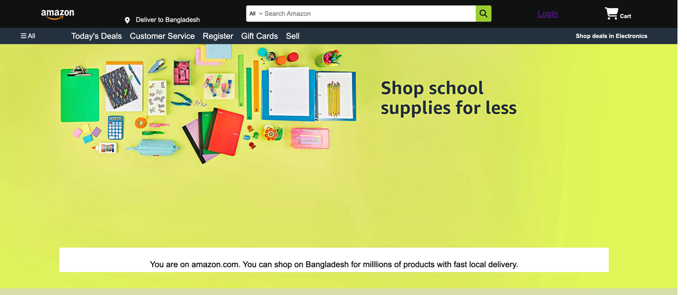

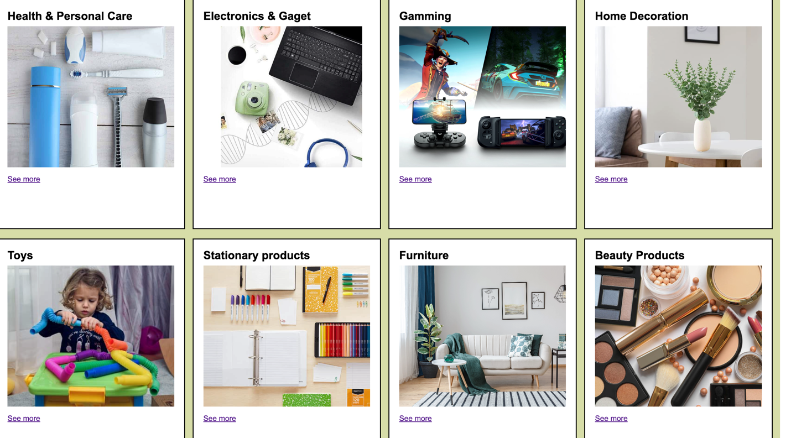

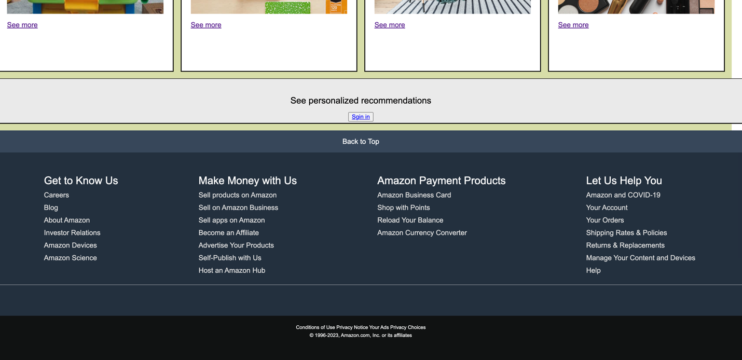

<!DOCTYPE html>

<html lang="en">

<head>

<meta charset="UTF-8">

<meta name="viewport" content="width=device-width, initial-scale=1.0">

<title>Amazon</title>

<link rel="stylesheet" href="https://cdnjs.cloudflare.com/ajax/libs/font-awesome/6.4.2/css/all.min.css" integrity="sha512-z3gLpd7yknf1YoNbCzqRKc4qyor8gaKU1qmn+CShxbuBusANI9QpRohGBreCFkKxLhei6S9CQXFEbbKuqLg0DA==" crossorigin="anonymous" referrerpolicy="no-referrer" />

<link rel="stylesheet" href="style.css">

</head>

<body>

<header>

<div class="navbar ">

<div class="nav-logo border">

<div class="logo"></div>

</div>

<div class="nav-address border">

<div class="add-icon">

<i class="fa-solid fa-location-dot"></i>

<p class="add-first">Deliver to Bangladesh</p>

</div>

</div>

<div class="nav-search">

<select class="search-select">

<option>All</option>

</select>

<input placeholder="Search Amazon" class="search-input">

<div class="search-icon">

<i class="fa-solid fa-magnifying-glass"></i>

</div>

</div>

<div class="nav-signin border">

<a href="Login.html">Login</a>

</div>

<div class="nav-cart border">

<i class="fa-solid fa-cart-shopping"></i>

Cart

</div>

</div>

<div class="panel">

<div class="panel-all">

<i class="fa-solid fa-bars"></i>

All

</div>

<div class="panel-ops">

<p>Today's Deals</p>

<p>Customer Service</p>

<p>Register</p>

<p>Gift Cards</p>

<p>Sell</p>

</div>

<div class="panel-deals">

Shop deals in Electronics

</div>

</div>

</header>

<div class="hero-section">

<div class="hero-msg">

<P>You are on amazon.com. You can shop on Bangladesh for milllions of products with fast local delivery.</P>

</div>

</div>

<div class="shop-section">

<div class="box1 box">

<div class="box-content">

<h2>Health & Personal Care</h2>

<div class="box-img" style="background-image: url('health_box1.jpg');"></div>

<a href="tab1.html" target="_blank">See more</a>

</div>

</div>

<div class="box2 box">

<div class="box-content">

<h2>Electronics & Gaget</h2>

<div class="box-img" style="background-image: url('electronics22_.jpg');"></div>

<a href="tab2.html" target="_blank">See more</a>

</div>

</div>

<div class="box3 box"> <div class="box-content">

<h2>Gamming</h2>

<div class="box-img" style="background-image: url('gamming_HERO.jpg');"></div>

<a href="tab3.html" target="_blank">See more</a>

</div>

</div>

<div class="box4 box"> <div class="box-content">

<h2>Home Decoration</h2>

<div class="box-img" style="background-image: url('homekitchen.jpg');"></div>

<a href="tab4.html" target="_blank">See more</a>

</div>

</div>

<div class="box5 box">

<div class="box-content">

<h2>Toys</h2>

<div class="box-img" style="background-image: url('toys944_.jpg');"></div>

<a href="tab5.html" target="_blank">See more</a>

</div>

</div>

<div class="box6 box">

<div class="box-content">

<h2>Stationary products</h2>

<div class="box-img" style="background-image: url('shop_school.jpg');"></div>

<a href="tab6.html" target="_blank">See more</a>

</div>

</div>

<div class="box7 box"> <div class="box-content">

<h2>Furniture</h2>

<div class="box-img" style="background-image: url('furniture_in.jpg');"></div>

<a href="tab7.html" target="_blank">See more</a>

</div>

</div>

<div class="box8 box"> <div class="box-content">

<h2>Beauty Products</h2>

<div class="box-img" style="background-image: url('product_beauty.jpg');"></div>

<a href="tab8.html" target="_blank">See more</a>

</div>

</div>

<footer>

<div class="signin">

<p>See personalized recommendations</p>

<a href="Login.html" target="_blank"><button class="sing" style="color: blue;">Sgin in </button> </a>

</div>

</footer>

<footer>

<div class="foot-panel1">

Back to Top

</div>

<div class="foot-panel2">

<ul>

<p>Get to Know Us</p>

<a>Careers</a>

<a>Blog</a>

<a>About Amazon</a>

<a>Investor Relations</a>

<a>Amazon Devices</a>

<a>Amazon Science</a>

</ul>

<ul>

<p>Make Money with Us</p>

<a>Sell products on Amazon</a>

<a>Sell on Amazon Business</a>

<a>Sell apps on Amazon</a>

<a>Become an Affiliate</a>

<a>Advertise Your Products</a>

<a>Self-Publish with Us</a>

<a>Host an Amazon Hub</a>

</ul>

<ul>

<p>Amazon Payment Products</p>

<a>Amazon Business Card</a>

<a>Shop with Points</a>

<a>Reload Your Balance</a>

<a>Amazon Currency Converter</a>

</ul>

<ul>

<p>Let Us Help You</p>

<a>Amazon and COVID-19</a>

<a>Your Account</a>

<a>Your Orders</a>

<a>Shipping Rates & Policies</a>

<a>Returns & Replacements</a>

<a>Manage Your Content and Devices</a>

<a>Help</a>

</ul>

</div>

<div class="foot-panel3">

<div class="logo"></div>

</div>

<div class="foot-panel4">

<div class="pages">

<a>Conditions of Use</a>

<a>Privacy Notice</a>

<a>Your Ads Privacy Choices</a>

</div>

<div class="copyright">

© 1996-2023, Amazon.com, Inc. or its affiliates

</div>

</div>

</footer>

</body>

</html>

**Css.style**

* {

margin: 0;

font-family: Arial, Helvetica, sans-serif;

border: border-box;

}

.navbar{

height: 70px;

background-color: #0F1111;

color: white;

display: flex;

align-items:center;

justify-content: space-evenly;

}

.nav-logo{

height: 50px;

width: 100px;

}

.logo{

background-image: url("amazon_logo.png");

background-size: cover;

height: 50px;

width: 100%;

}

.border{

border: 1.5px solid transparent;

}

.border:hover{

border: 1.5px solid white;

}

.add-first{

color: white;

font-size: 1rem;

margin-left: 15px;

}

.add-icon{

display: flex;

align-items: flex-end;

}

.nav-search {

display: flex;

justify-content: space-evenly;

background-color: pink;

width: 600px;

height: 40px;

border-radius: 4px;

}

.search-select {

background-color: white;

width: 50px;

text-align: center;

border-top-left-radius:4px;

border-bottom-left-radius: 4px;

border: none;

}

.search-input {

width: 100%;

font-size: 1rem;

border: none;

}

.search-icon {

width: 45px;

display: flex;

justify-content: center;

align-items: center;

font-size: 1.2rem;

background-color: yellowgreen;

border-top-right-radius: 4px;

border-bottom-right-radius: 4px;

color: #0F1111;

}

.nav-search:hover {

border: 2px solid orange;

}

.span {

font-size: 0.7rem;

}

.nav-cart i {

font-size: 30px;

}

.nav-cart {

font-size: 0.85rem;

font-weight: 700;

}

.nav-signin{

color: #fff;

font-size: 20px;

;

}

.panel {

height: 40px;

background-color: #222f3d;

display: flex;

color: white;

align-items: center;

justify-content: space-evenly;

}

.panel-ops p {

display: inline;

margin-left: 15px;

font-size: 20px;

}

.panel-ops {

width: 70%;

font-size: 1rem;

color: #fff;

}

.panel-deals {

font-size: 0.9rem;

font-weight: 700;

}

/** main section**/

.hero-section {

background-image: url("one_m.jpg");

background-size: cover;

height: 600px;

display: flex;

justify-content: center;

align-items: flex-end;

}

.hero-msg{

background-color: white;

font-size: 160%;

color: black;

height: 60px;

display: flex;

align-items: top;

justify-content: center;

width: 80%;

margin-bottom: 40px;

}

/** shop section **/

.shop-section {

display: flex;

flex-wrap: wrap;

justify-content: space-evenly;

background-color: rgb(215, 221, 169);

}

.box {

border: 2px solid black ;

height: 450px;

width: 23%;

background-color: white;

padding: 20px 5px 15px;

margin-top: 20px;

}

.box-img {

height: 300px;

background-size: cover;

margin-top: 0.5rem;

margin-bottom: 1rem;

}

.box-content {

margin-left: 1rem;

margin-right: 1rem;

}

.box-content p {

color: rgba(21, 127, 208, 0.736);

}

.signin {

margin-top: 15px;

border-top: 1px solid black;

border-bottom: 2px solid black;

min-width: 1800px;

height: 100px;

background-color: rgb(235, 234, 234);

}

.signin p {

display: flex;

justify-content: center;

align-items: center;

margin-top: 8px;

;

}

.signin a {

display: flex;

justify-content: center;

align-items: center;

margin-top: 15px;

color:rgb(37, 17, 219);

font-size: 20px;

}

.foot-panel1 {

background-color: #37475a;

color: white;

height: 50px;

display: flex;

justify-content: center;

align-items: center;

font-size: 1rem;

min-width: 1800px;

margin-top: 15px;

}

.foot-panel2 {

background-color: #222f3d;

color: white;

height: 300px;

display: flex;

justify-content: space-evenly;

}

ul a {

display: block;

font-size: 1rem;

margin-top: 10px;

color: #dddddd;

}

ul p {

font-size: 1.5rem;

}

ul {

margin-top: 20px;

}

.foot-panel3 {

background-color: #222f3d;

color: white;

border-top: 0.5px solid white;

height: 70px;

display: flex;

justify-content: center;

align-items: center;

}

.logo{

background-image: url("amazon_logo.png");

background-size: cover;

height: 50px;

width: 100%;

}

.foot-panel4 {

background-color: #0F1111;

color: white;

height: 100px;

}

.pages {

font-size: 0.7rem;

text-align: center;

padding-top: 20px;

}

.copyright {

padding-top: 5px;

font-size: 0.7rem;

text-align: center;

}

.login-container {

width: 300px;

margin: 0 auto;

margin-top: 100px;

padding: 20px;

background-color: #fff;

border: 1px solid #ccc;

border-radius: 5px;

padding: 40px;

}

input[type="text"], input[type="password"] {

width: 100%;

padding: 10px;

margin: 5px 0;

border: 1px solid #ccc;

border-radius: 3px;

}

input[type="submit"] {

width: 100%;

background-color: #4CAF50;

color: #fff;

padding: 10px;

border: none;

border-radius: 3px;

cursor: pointer;

}

p{

font-size: 20px;

padding-top: 30px;

}

.registration-container {

width: 300px;

margin: 0 auto;

margin-top: 100px;

padding: 40px;

background-color: #fff;

border: 1px solid #ccc;

border-radius: 5px;

box-shadow: 0 2px 4px rgba(0, 0, 0, 0.1);

font-size: 20px;

}

input[type="text"],

input[type="email"],

input[type="password"] {

width: 100%;

padding: 10px;

margin: 10px 0;

border: 1px solid #ccc;

border-radius: 3px;

}

input[type="submit"] {

width: 100%;

background-color: #4CAF50;

color: #fff;

padding: 10px;

border: none;

border-radius: 3px;

cursor: pointer;

}

**Login Page**

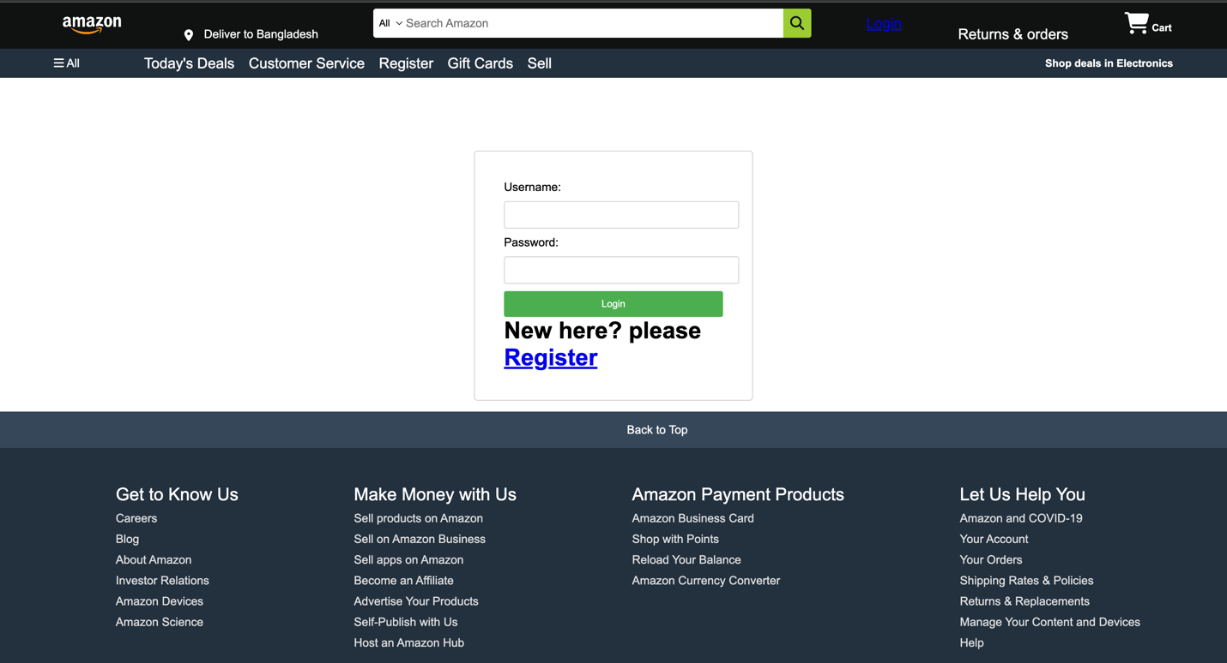

<!DOCTYPE html>

<html lang="en">

<head>

<meta charset="UTF-8">

<meta name="viewport" content="width=device-width, initial-scale=1.0">

<title>Document</title>

<link rel="stylesheet" href="https://cdnjs.cloudflare.com/ajax/libs/font-awesome/6.4.2/css/all.min.css" integrity="sha512-z3gLpd7yknf1YoNbCzqRKc4qyor8gaKU1qmn+CShxbuBusANI9QpRohGBreCFkKxLhei6S9CQXFEbbKuqLg0DA==" crossorigin="anonymous" referrerpolicy="no-referrer" />

<link rel="stylesheet" href="style.css">

</head>

<body>

<header>

<div class="navbar ">

<div class="nav-logo border">

<div class="logo"></div>

</div>

<div class="nav-address border">

<div class="add-icon">

<i class="fa-solid fa-location-dot"></i>

<p class="add-first">Deliver to Bangladesh</p>

</div>

</div>

<div class="nav-search">

<select class="search-select">

<option>All</option>

</select>

<input placeholder="Search Amazon" class="search-input">

<div class="search-icon">

<i class="fa-solid fa-magnifying-glass"></i>

</div>

</div>

<div class="nav-signin border">

<a href="Login.html">Login</a>

</div>

<div class="nav-return border">

<p><span>Returns & orders</span></p>

</div>

<div class="nav-cart border">

<i class="fa-solid fa-cart-shopping"></i>

Cart

</div>

</div>

<div class="panel">

<div class="panel-all">

<i class="fa-solid fa-bars"></i>

All

</div>

<div class="panel-ops">

<p>Today's Deals</p>

<p>Customer Service</p>

<p> Register</p>

<p>Gift Cards</p>

<p>Sell</p>

</div>

<div class="panel-deals">

Shop deals in Electronics

</div>

</div>

</header>

<div class="login-container">

<h2><a href="index.html"></a></h2>

<form action="login.php" method="post">

<label for="username">Username:</label>

<input type="text" name="username" id="username" required>

<label for="password">Password:</label>

<input type="password" name="password" id="password" required>

<input type="submit" value="Login">

</form>

<h1 class="loginh1">New here? please <a class="anchor" href="register.html">Register</a> </h1>

</div>

</body>

<footer>

<div class="foot-panel1">

Back to Top

</div>

<div class="foot-panel2">

<ul>

<p>Get to Know Us</p>

<a>Careers</a>

<a>Blog</a>

<a>About Amazon</a>

<a>Investor Relations</a>

<a>Amazon Devices</a>

<a>Amazon Science</a>

</ul>

<ul>

<p>Make Money with Us</p>

<a>Sell products on Amazon</a>

<a>Sell on Amazon Business</a>

<a>Sell apps on Amazon</a>

<a>Become an Affiliate</a>

<a>Advertise Your Products</a>

<a>Self-Publish with Us</a>

<a>Host an Amazon Hub</a>

</ul>

<ul>

<p>Amazon Payment Products</p>

<a>Amazon Business Card</a>

<a>Shop with Points</a>

<a>Reload Your Balance</a>

<a>Amazon Currency Converter</a>

</ul>

<ul>

<p>Let Us Help You</p>

<a>Amazon and COVID-19</a>

<a>Your Account</a>

<a>Your Orders</a>

<a>Shipping Rates & Policies</a>

<a>Returns & Replacements</a>

<a>Manage Your Content and Devices</a>

<a>Help</a>

</ul>

</div>

<div class="foot-panel3">

<div class="logo"></div>

</div>

<div class="foot-panel4">

<div class="pages">

<a>Conditions of Use</a>

<a>Privacy Notice</a>

<a>Your Ads Privacy Choices</a>

</div>

<div class="copyright">

© 1996-2023, Amazon.com, Inc. or its affiliates

</div>

</div>

</footer>

</body>

</html>

</html>

**Register page**

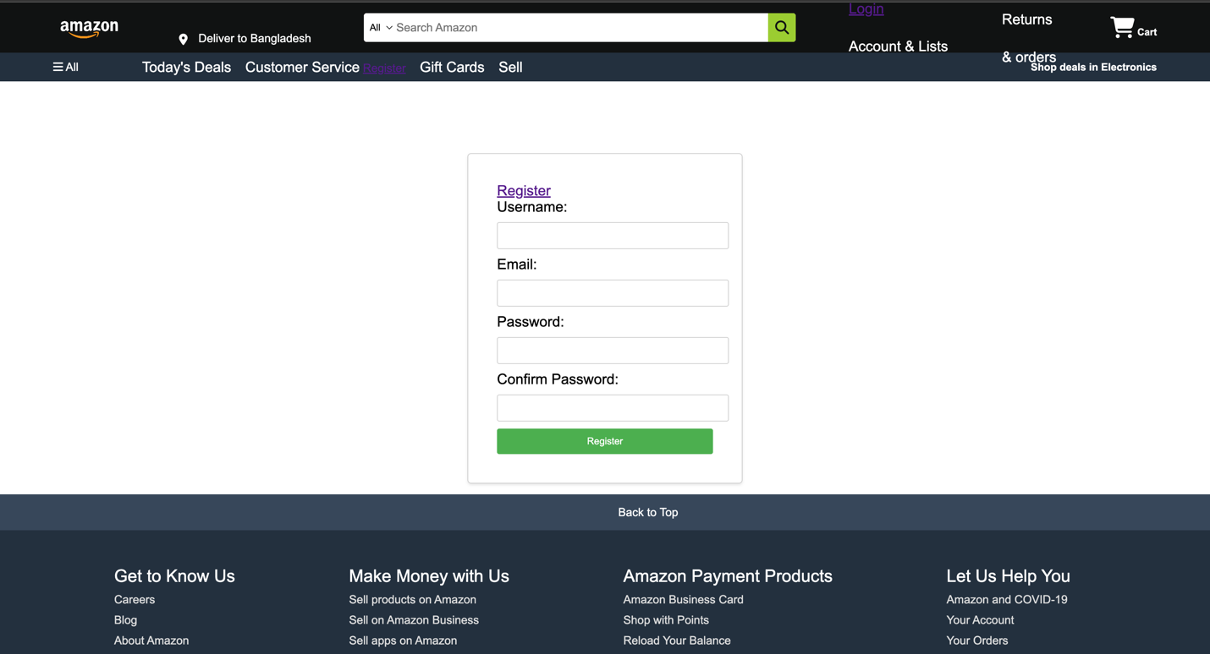

<!DOCTYPE html>

<html lang="en">

<head>

<meta charset="UTF-8">

<meta name="viewport" content="width=device-width, initial-scale=1.0">

<title>Amazon</title>

<link rel="stylesheet" href="https://cdnjs.cloudflare.com/ajax/libs/font-awesome/6.4.2/css/all.min.css" integrity="sha512-z3gLpd7yknf1YoNbCzqRKc4qyor8gaKU1qmn+CShxbuBusANI9QpRohGBreCFkKxLhei6S9CQXFEbbKuqLg0DA==" crossorigin="anonymous" referrerpolicy="no-referrer" />

<link rel="stylesheet" href="style.css">

</head>

<body>

<header>

<div class="navbar ">

<div class="nav-logo border">

<div class="logo"></div>

</div>

<div class="nav-address border">

<div class="add-icon">

<i class="fa-solid fa-location-dot"></i>

<p class="add-first">Deliver to Bangladesh</p>

</div>

</div>

<div class="nav-search">

<select class="search-select">

<option>All</option>

</select>

<input placeholder="Search Amazon" class="search-input">

<div class="search-icon">

<i class="fa-solid fa-magnifying-glass"></i>

</div>

</div>

<div class="nav-signin border">

<a href="Login.html">Login</a>

<p class="nav-second">Account & Lists</p>

</div>

<div class="nav-return border">

<p><span>Returns</span></p>

<p class="nav-second">& orders</p>

</div>

<div class="nav-cart border">

<i class="fa-solid fa-cart-shopping"></i>

Cart

</div>

</div>

<div class="panel">

<div class="panel-all">

<i class="fa-solid fa-bars"></i>

All

</div>

<div class="panel-ops">

<p>Today's Deals</p>

<p>Customer Service</p>

<a href="register.html">Register</a>

<p>Gift Cards</p>

<p>Sell</p>

</div>

<div class="panel-deals">

Shop deals in Electronics

</div>

</div>

</header>

<div class="registration-container">

<a href="index.html" target="_blank">Register</a>

<form action="register.php" method="post">

<label for="username">Username:</label>

<input type="text" name="username" id="username" required>

<label for="email">Email:</label>

<input type="email" name="email" id="email" required>

<label for="password">Password:</label>

<input type="password" name="password" id="password" required>

<label for="confirm-password">Confirm Password:</label>

<input type="password" name="confirm-password" id="confirm-password" required>

<input type="submit" value="Register">

</form>

</div>

</body>

<footer>

<div class="foot-panel1">

Back to Top

</div>

<div class="foot-panel2">

<ul>

<p>Get to Know Us</p>

<a>Careers</a>

<a>Blog</a>

<a>About Amazon</a>

<a>Investor Relations</a>

<a>Amazon Devices</a>

<a>Amazon Science</a>

</ul>

<ul>

<p>Make Money with Us</p>

<a>Sell products on Amazon</a>

<a>Sell on Amazon Business</a>

<a>Sell apps on Amazon</a>

<a>Become an Affiliate</a>

<a>Advertise Your Products</a>

<a>Self-Publish with Us</a>

<a>Host an Amazon Hub</a>

</ul>

<ul>

<p>Amazon Payment Products</p>

<a>Amazon Business Card</a>

<a>Shop with Points</a>

<a>Reload Your Balance</a>

<a>Amazon Currency Converter</a>

</ul>

<ul>

<p>Let Us Help You</p>

<a>Amazon and COVID-19</a>

<a>Your Account</a>

<a>Your Orders</a>

<a>Shipping Rates & Policies</a>

<a>Returns & Replacements</a>

<a>Manage Your Content and Devices</a>

<a>Help</a>

</ul>

</div>

<div class="foot-panel3">

<div class="logo"></div>

</div>

<div class="foot-panel4">

<div class="pages">

<a>Conditions of Use</a>

<a>Privacy Notice</a>

<a>Your Ads Privacy Choices</a>

</div>

<div class="copyright">

© 1996-2023, Amazon.com, Inc. or its affiliates

</div>

</div>

</footer>

</html>

**Categories of Products**

